**Recipe Book Project Report**

**1. Project Title**

**Recipe Book Web Application**

**2. Project Objective**

The objective of this project is to create an interactive web application that allows users to browse, search, and view various recipes. The project is developed using **HTML, CSS, and JavaScript**, providing a dynamic and user-friendly interface for users to explore recipes easily.

**3. Supported Technologies**

* **HTML**: Used for structuring the content of the web pages.
* **CSS**: Used for styling the web pages and making the interface visually appealing.
* **JavaScript**: Used to add interactivity to the web application, such as filtering recipes, search functionality, and dynamic content updates.

**4. Features**

1. **Recipe Display**: All recipes are displayed as cards with the recipe name, image, and description.
2. **Search Functionality**: Users can search for recipes by name or ingredient.
3. **Filter Options**: Recipes can be filtered based on categories like Breakfast, Lunch, Dinner, and Dessert.
4. **Responsive Design**: The web application is fully responsive and works on both desktop and mobile devices.
5. **Dynamic Updates**: Recipes are dynamically displayed using JavaScript without reloading the page.

**5. Project Modules**

**5.1 HTML Module**

* Contains the structure of the web pages.
* Main elements include navigation bar, search input, recipe cards container, and footer.

**5.2 CSS Module**

* Provides styling for the navigation bar, recipe cards, buttons, and overall page layout.
* Uses **Flexbox/Grid** for responsive design.
* Adds animations and hover effects to enhance user experience.

**5.3 JavaScript Module**

* Handles dynamic operations like:
  + Filtering recipes by category.
  + Searching recipes by keyword.
  + Rendering recipe cards dynamically from an array of recipe objects.
  + Event handling for buttons and search input.

**6. Sample Code Snippets**

**HTML Example**

<div class="recipe-card">

<img src="recipe-image.jpg" alt="Recipe Image">

<h3>Recipe Name</h3>

<p>Short description of the recipe.</p>

</div>

**CSS Example**

.recipe-card {

border: 1px solid #ccc;

border-radius: 10px;

padding: 15px;

text-align: center;

transition: transform 0.3s;

}

.recipe-card:hover {

transform: scale(1.05);

}

**JavaScript Example**

const recipes = [

{ name: "Pasta", category: "Lunch", description: "Delicious Italian pasta." },

{ name: "Chocolate Cake", category: "Dessert", description: "Rich and moist cake." }

];

function displayRecipes(filteredRecipes = recipes) {

const recipeList = document.getElementById("recipe-list");

recipeList.innerHTML = "";

filteredRecipes.forEach(recipe => {

recipeList.innerHTML += `

<div class="recipe-card">

<h3>${recipe.name}</h3>

<p>${recipe.description}</p>

</div>

`;

});

}

**7. Project Screenshots**

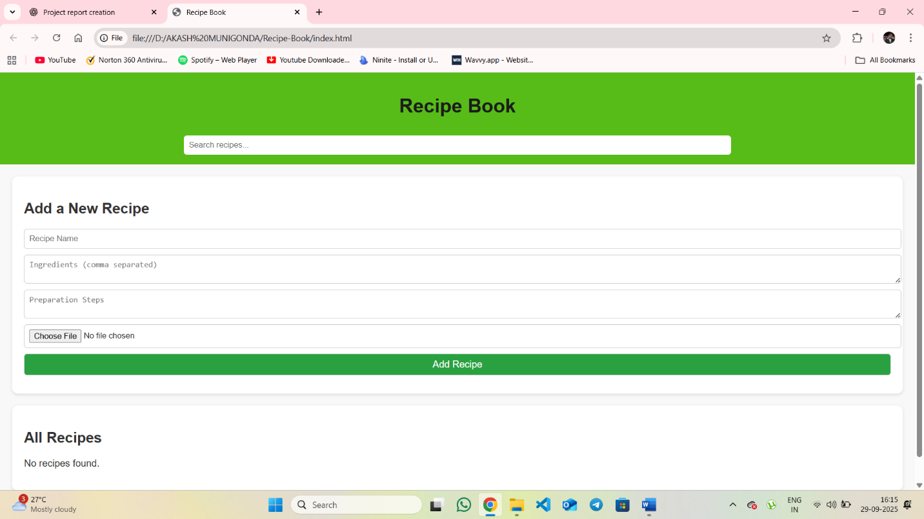

Home page with recipe list

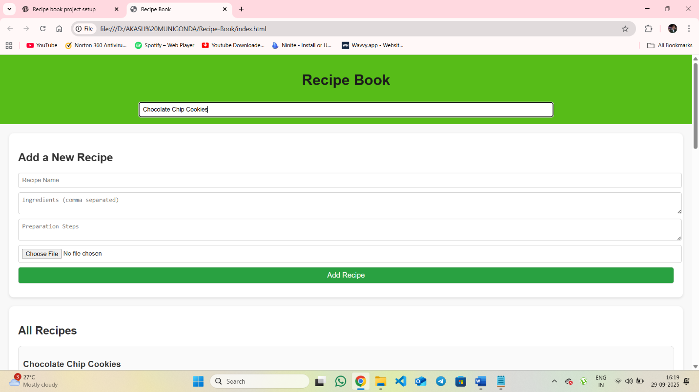

Search functionality in action

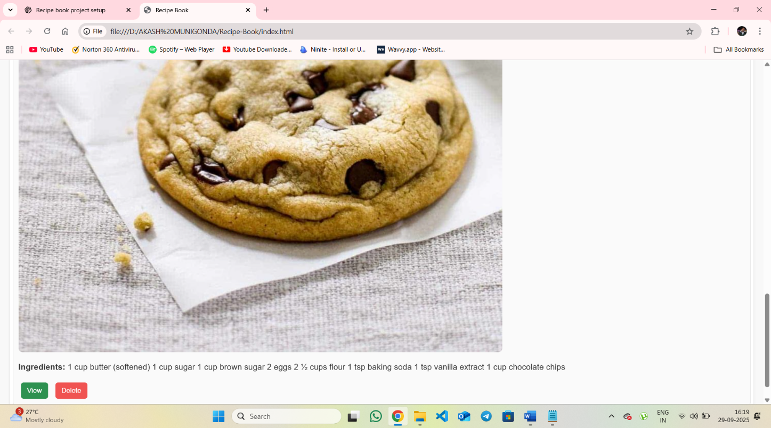

Responsive view

**8. Challenges Faced**

* Designing a responsive layout for different screen sizes.
* Implementing dynamic search and filter using JavaScript.
* Ensuring smooth user experience with animations and transitions.

**9. Conclusion**

The Recipe Book project demonstrates the use of **HTML, CSS, and JavaScript** to build an interactive web application. Users can easily browse, search, and filter recipes, making the application a useful and engaging tool for recipe management. This project enhances knowledge in front-end development and dynamic web design.